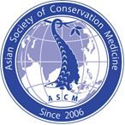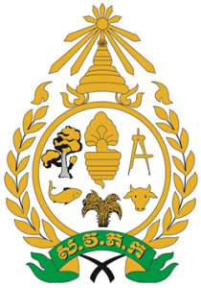
The International Meeting of Asian Society of Conservation Medicine (ASCM) in Phnom Penh, Cambodia 2019

Venue: Hotel Cambodiana, Phnom Penh, Kingdom of Cambodia
Date: October 25th – 27th, 2019 (Please refer to Tentative Schedule)
ASCM Link: http://2019cambodia.ascm-aszwm.org/

Registration fee
Early bird: April – June 30
 | International | Local (Cambodia)
Regular | 200 USD | 50 USD
Student | 120 USD | 50 USD
Late registration: July 1 – October 27 |  | 50 USD
Regular | 250 USD | 50 USD
Student | 150 USD | 50 USD

Call for paper: April – August 31, 2019

Pre-congress workshops (October 25, 2019)
- One Health Educational Workshop (FREE, prioritize local participants) (Half-day)
Dr. Bambang Pontjo Priosoeryanto: Opening remark
Dr. Toshio Tsubota: Wildlife Biology and Medicine for One Health
Dr. Paolo Martelli: Introduction to Zoo Medicine
Dr. Pam Whiteley: One Health Concept and Wildlife Disease Surveillance
Dr. James K. Chambers: General Pathology
- Practical Approach to Avian Medicine (120 USD)
Dr. Alex Grioni and Dr. Serena Chung
- Wildlife Dental Workshop Level 1 (180 USD)
Dr. Cedric Tutt and Taipei Zoo staff
- Postmortem and Clinical Pathology (120 USD)
Dr. Chia-Da Hsu and Dr. Li-Wen Chang
Tentative schedule
DATE | PROGRAM
October 25th (Friday) |  | - Pre-conference Workshops at RUA: (One Health Educational Workshop, Practical Approach to Avian Medicine, Wildlife Dental Workshop Level 1 and Postmortem and Clinical Pathology)  - Ice Breaker (evening)  - ASCM/ACCM Board Meeting for board members only
October 26th (Saturday) |  | Main Meeting Day 1 ASCM:  - Opening Ceremony  - Keynote and Plenary Sessions  - General Sessions  - Banquet Dinner
October 27th (Sunday) |  | Main Meeting Day 2 ASCM:  - Plenary sessions  - General Sessions  - ASCM Closing Ceremony
October 28th (Monday) |  | - ACCM Diploma Examination  - Departure

Contacts
ASCM editor@aszwm.org

Organizing Hosts
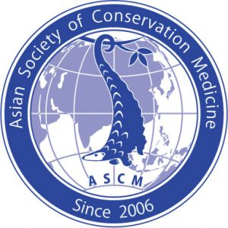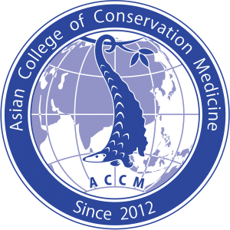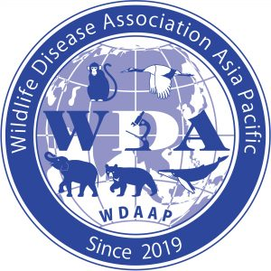
Supported by
